VCS Task

Task Description:

Establish a new directory, populate it with script files, initiate an empty repository on GitHub, convert the local directory into a Git repository, and link it to GitHub for pushing the code into the repository.Perform merge, rebase, stash commands in following github repo.

GIT MERGE
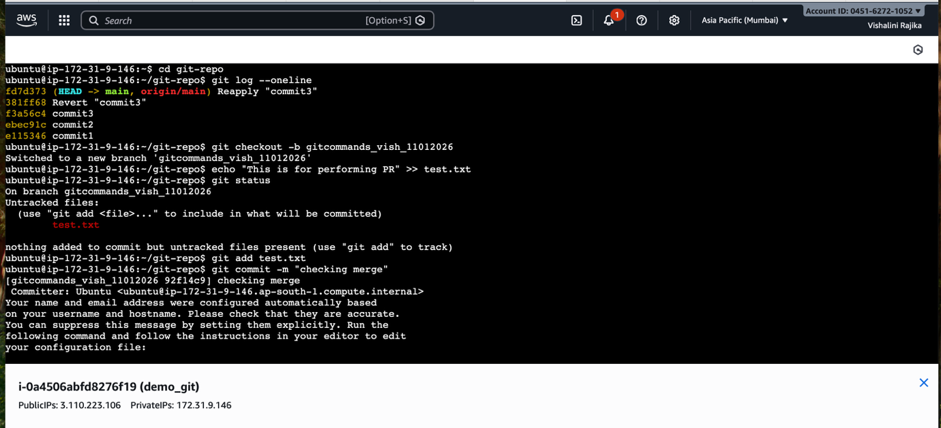
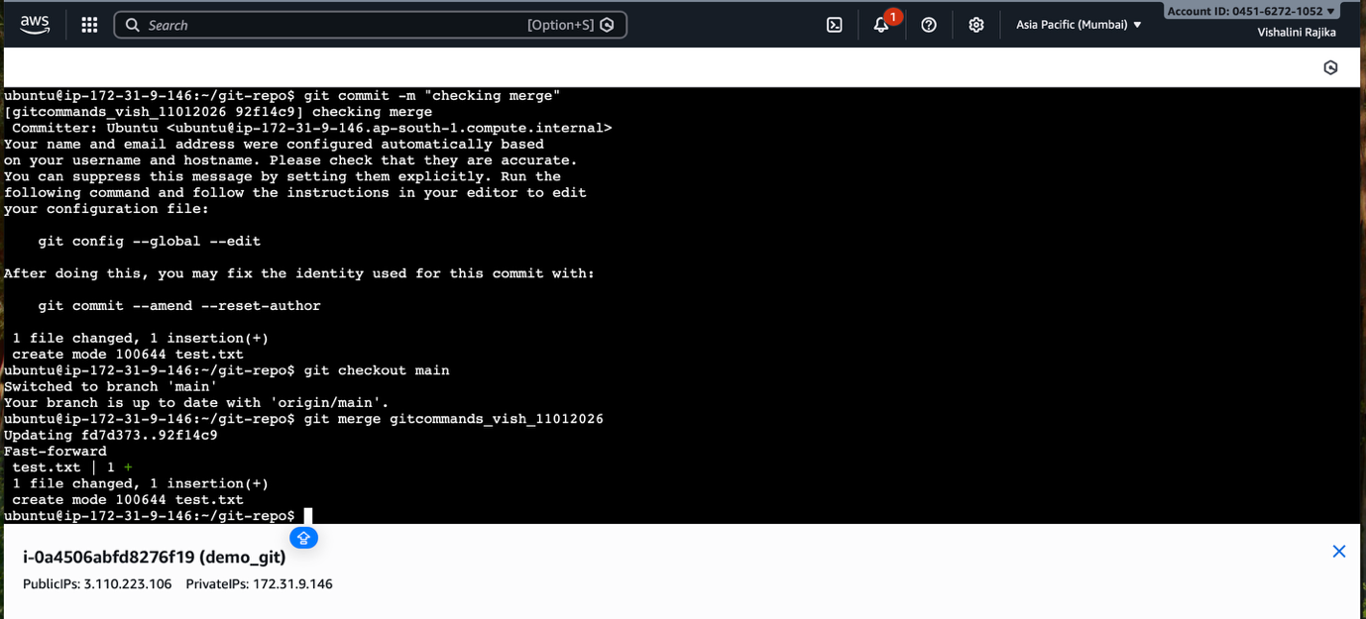
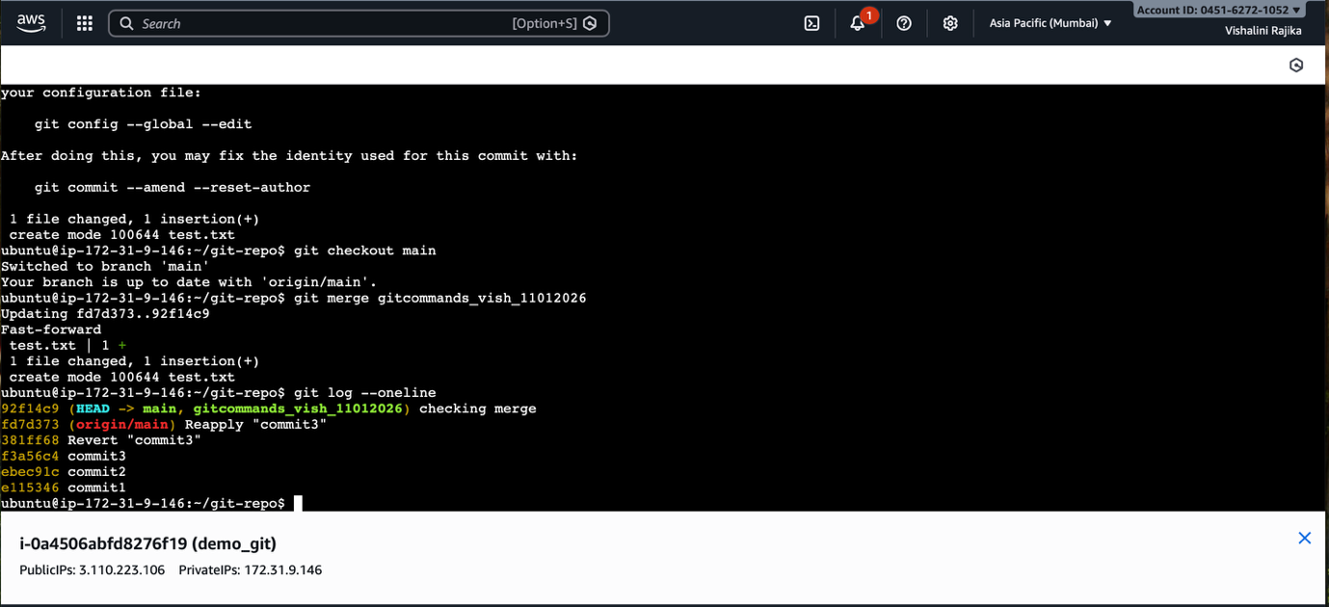

Merged my local branch to target branch
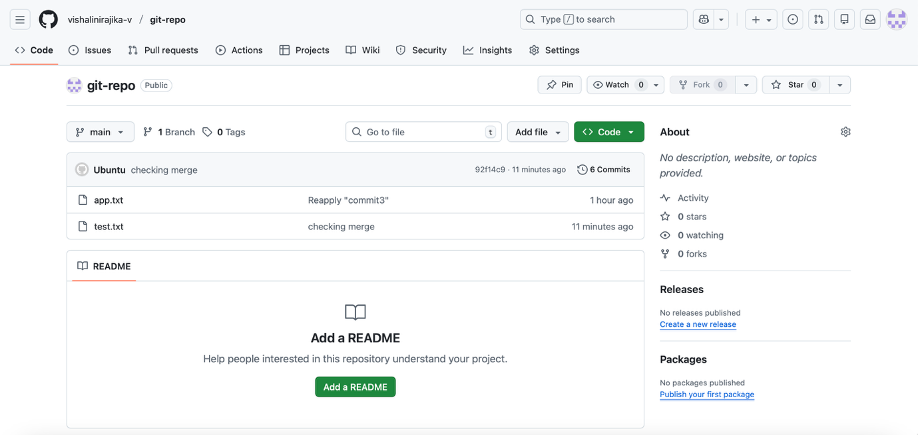

GIT REBASE
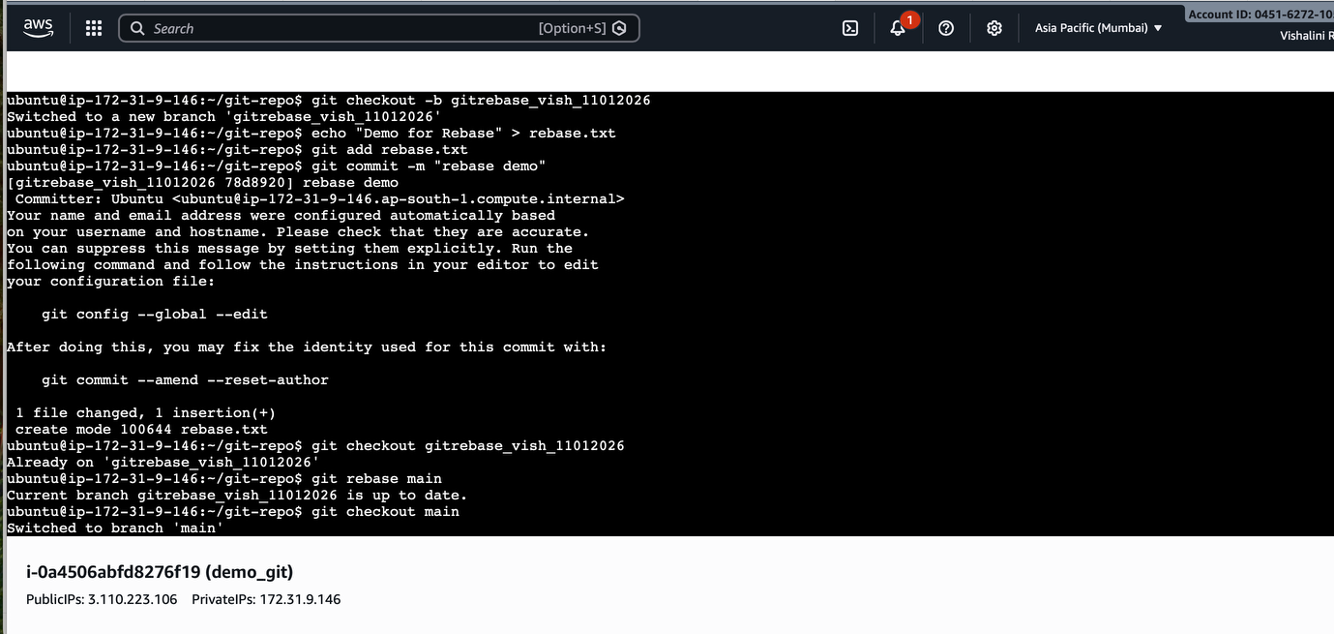
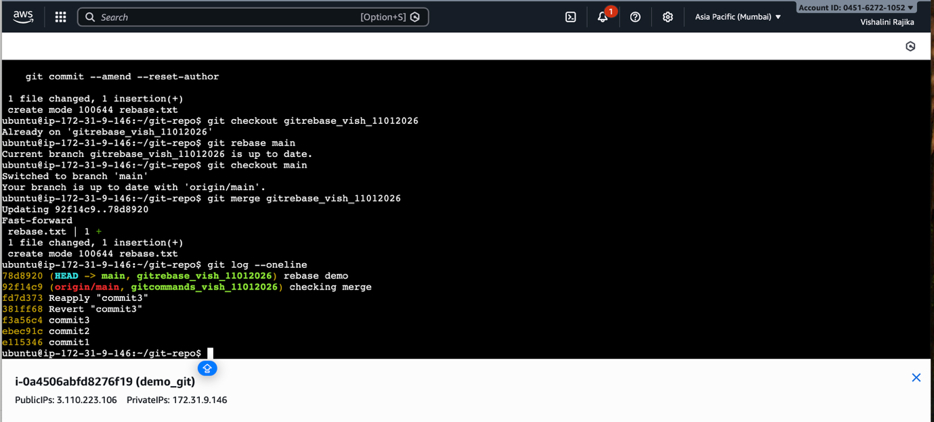
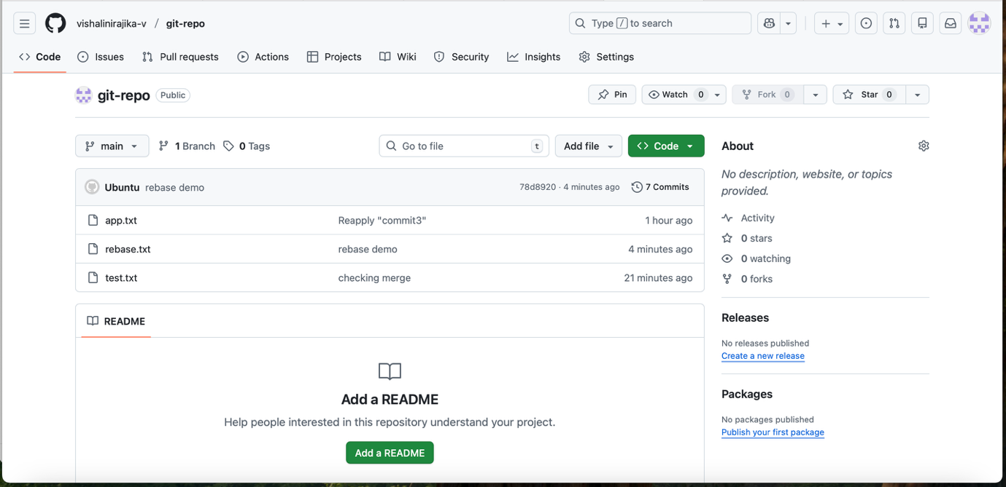
GIT STASH
